1. Implement a function for displaying negative of an input image. Note that the function must handle binary, grayscale, and RGB images. Example of RGB negative:

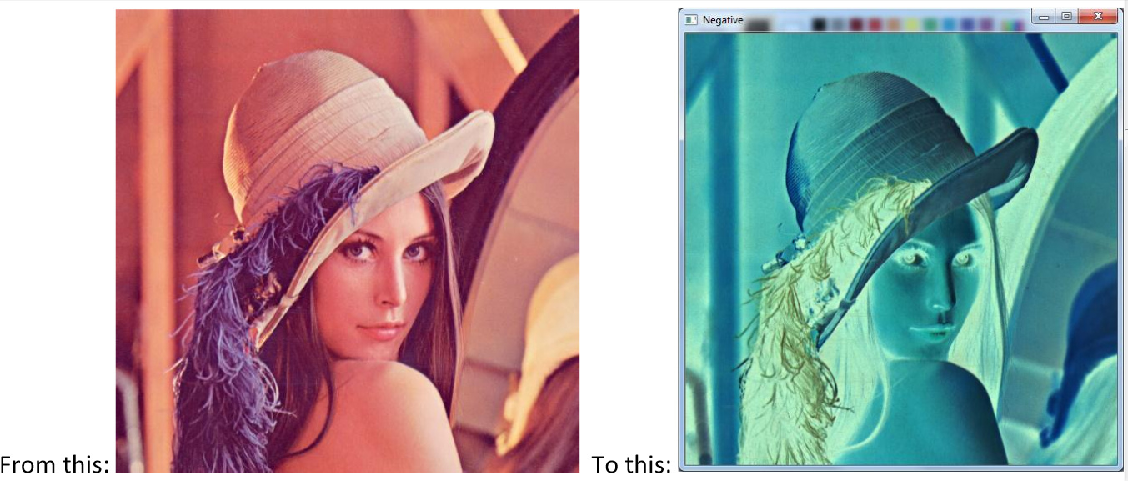

1. The horizontal gradient image can be used to detect vertical edges in an image. How, do you think? Implement a function for displaying the horizontal gradient of a grayscale image. The gradient can be approximated by forward differences:

Note that the gradient values can be both positive and negative! So you need to find a way to display the gradient values in the range: 0, 1, 2, …, 255. The following link can be helpful here:

<https://www.cis.rit.edu/people/faculty/rhody/EdgeDetection.htm>

The resulting image should look something like this:

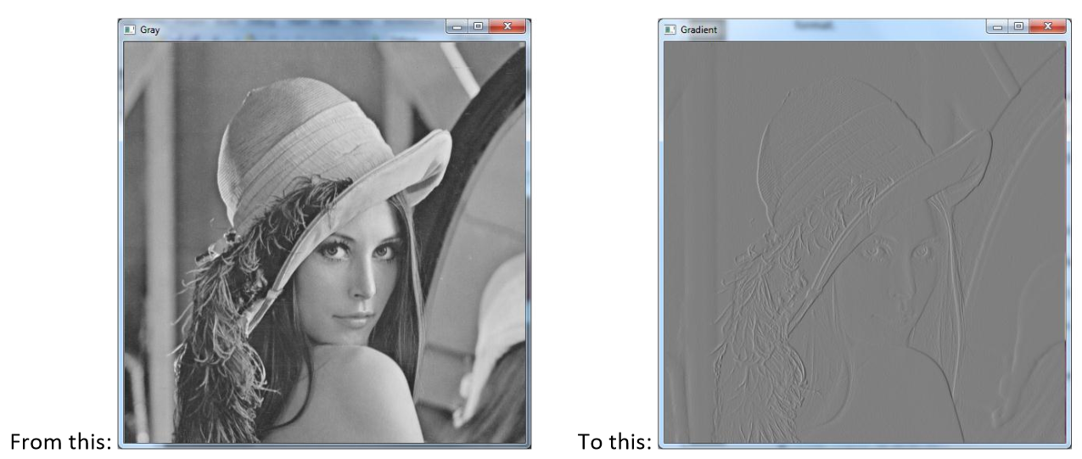

**Deliverable**

Hand in the source code from this lab at the appropriate location on the blackboard system at LMS.

Please make sure that you submit the following contents:-

A zipped folder containing all the .py files,all output images,a document containing code and output screenshots for all the codes.